**Objective:** This SOP outlines the steps to create and manage an Asana account effectively for project management.

**Link to Loom:** <https://loom.com/share/46cb7d5fd5484631940f497127eee59a>

**Key Steps**

**Introduction to Asana** [0:00](https://loom.com/share/46cb7d5fd5484631940f497127eee59a?t=0)

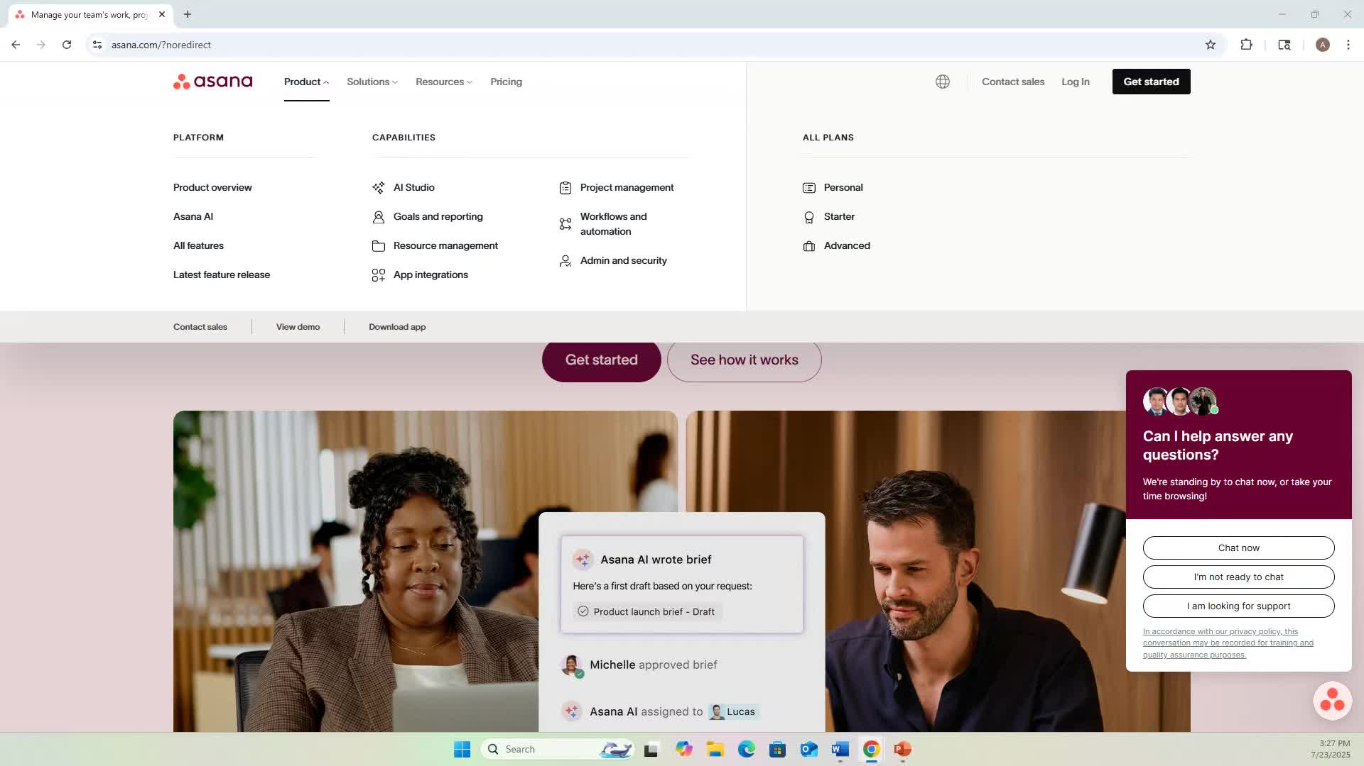

* Asana is a customizable work management platform used by various companies.
* It includes features like AI support, project management, goal tracking, task organization, and reporting.

**Logging into Asana** [2:25](https://loom.com/share/46cb7d5fd5484631940f497127eee59a?t=145)



* Use your company email to log in or create a free account using Google.
* If your organization uses Asana, request a login from your administrator.

**Customizing Your Home Space** [2:51](https://loom.com/share/46cb7d5fd5484631940f497127eee59a?t=171)

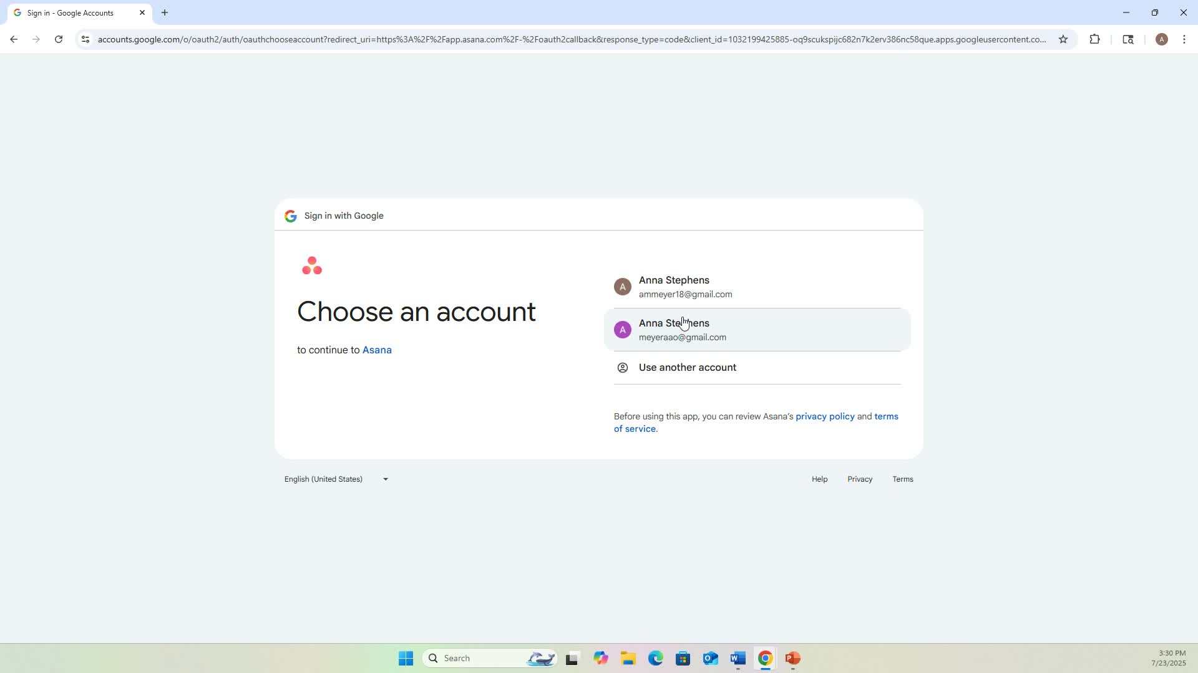

* Once logged in, customize your background color and add widgets to your home space.
* Recommended widgets:
  + Private Notepad: For quick notes.
  + Projects: See projects assigned to you or recently accessed.
  + My Tasks: See tasks assigned to you.
  + Forms: See recent forms you’ve accessed and star forms to save.
  + Draft Comments: To save comments you haven't sent.
  + Portfolios: To manage multiple projects.

**Creating a Project** [9:48](https://loom.com/share/46cb7d5fd5484631940f497127eee59a?t=588)

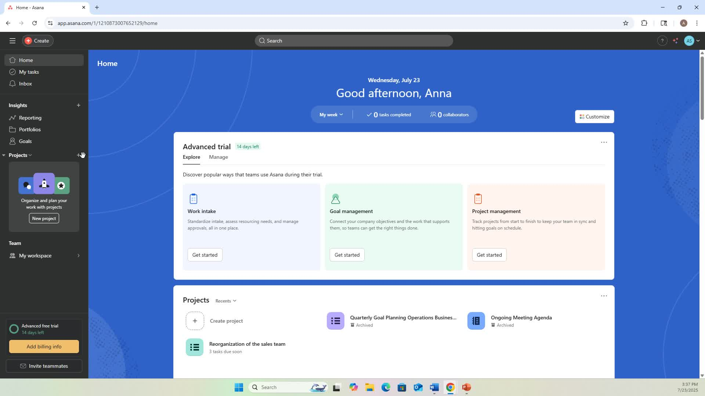

* Navigate to the home page and select 'Create a Project'.
* Choose 'Blank Project' and name it (e.g., 'Goal Planning for Sales Team').
* Set privacy settings as needed.

**Adding Tasks to Your Project** [12:36](https://loom.com/share/46cb7d5fd5484631940f497127eee59a?t=756)

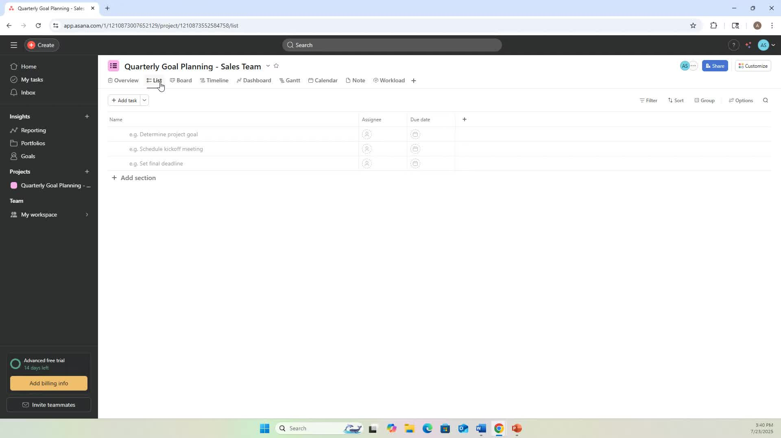

* In the project, switch to the list view for easier management.
* Click 'Add Task' and enter task details (e.g., 'Determine final goals').
* Assign tasks to team members as necessary.

**Using Asana AI for Task Management** [6:15](https://loom.com/share/46cb7d5fd5484631940f497127eee59a?t=375)

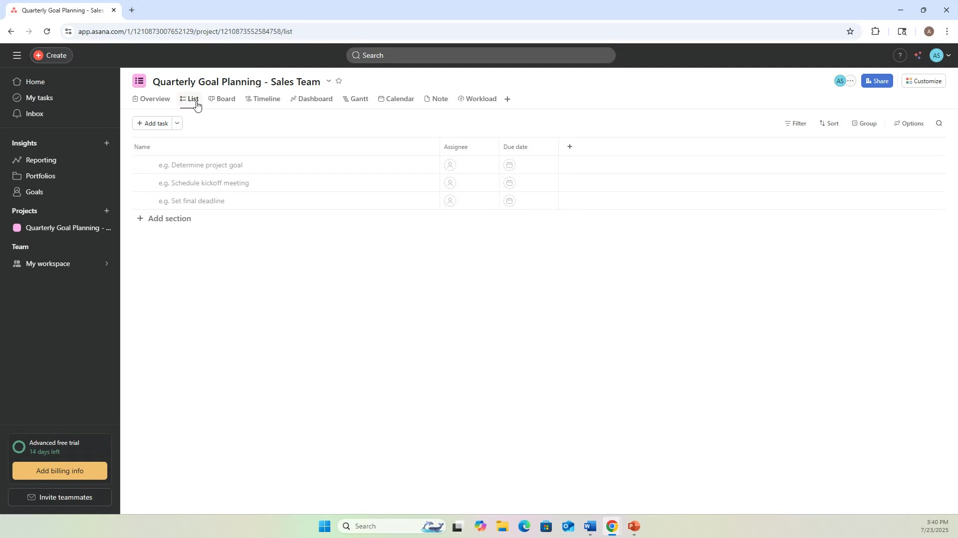

* Utilize Asana AI to create tasks or projects by typing commands (e.g., 'Create a project with...').
* This feature can help streamline task creation.

**Creating Forms for Work Requests** [25:17](https://loom.com/share/46cb7d5fd5484631940f497127eee59a?t=1517)

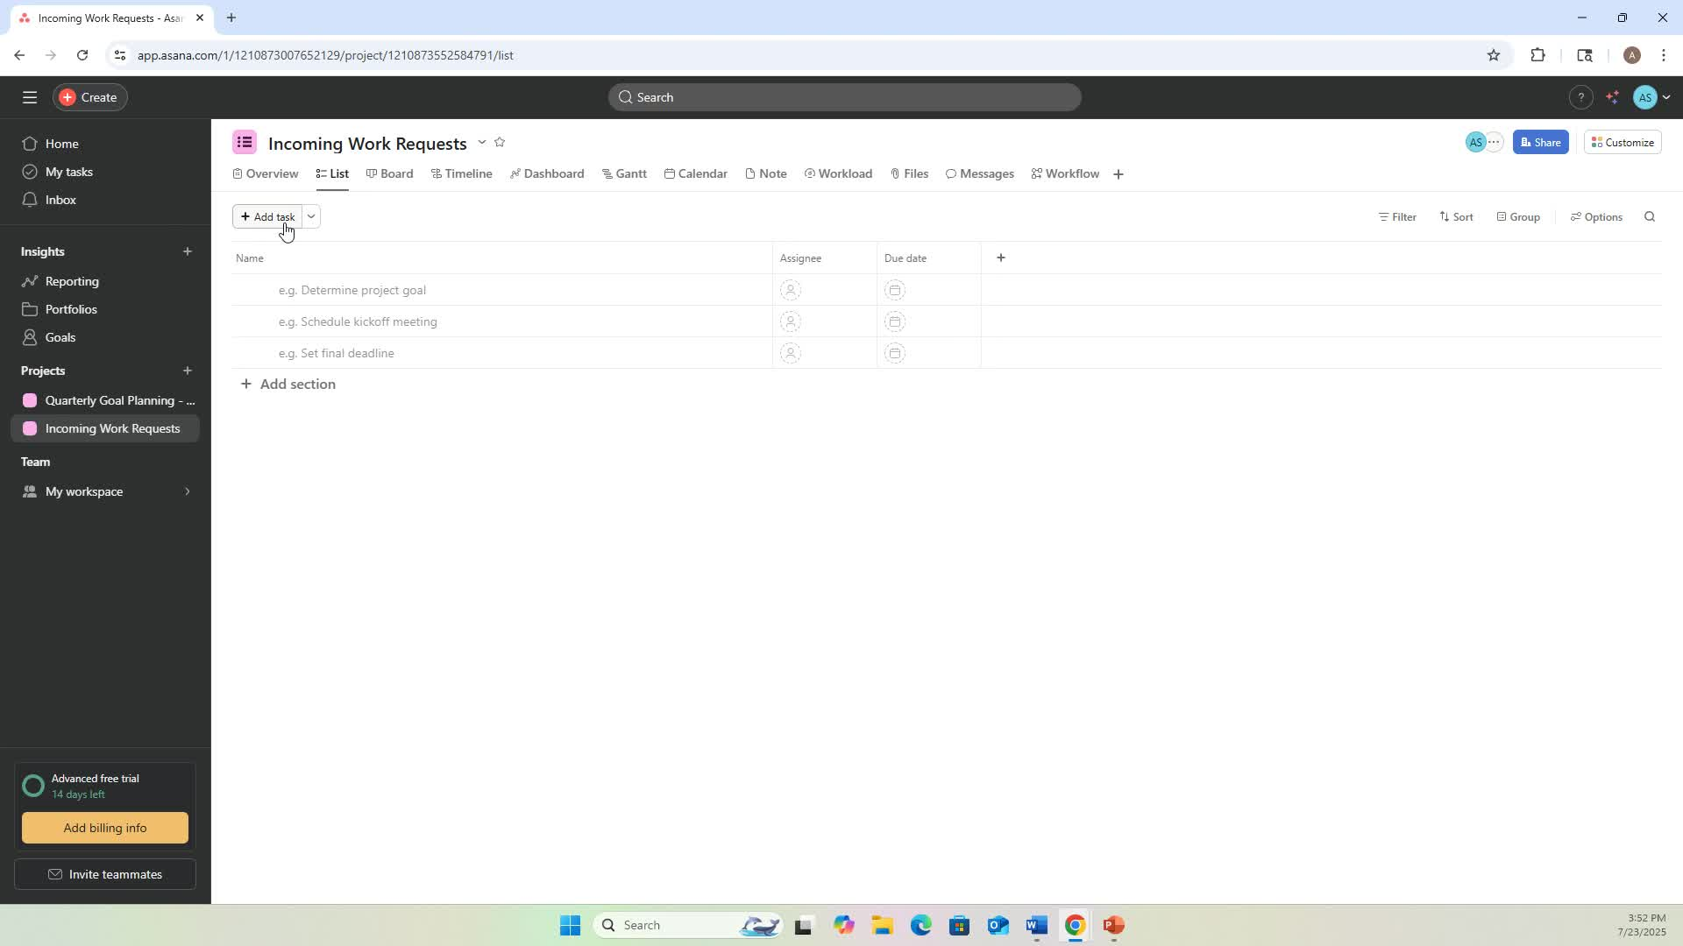

* Start a form to collect incoming work requests.
* Add fields for name, email, and specific questions related to the request.
* Publish the form for team use.

**Tracking Incoming Requests** [31:03](https://loom.com/share/46cb7d5fd5484631940f497127eee59a?t=1863)

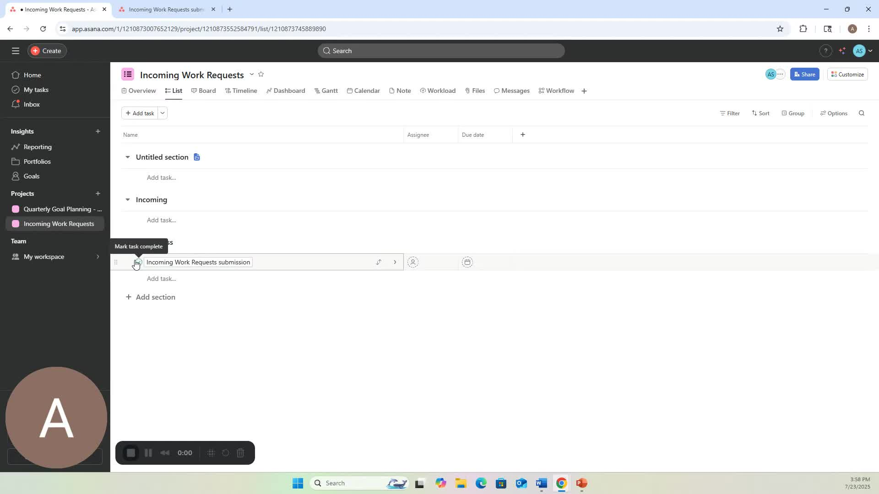

* Use the incoming work requests project to manage and assign tasks based on requests.
* Ensure tasks are assigned to the correct team members.

**Creating Custom Fields and Automations** [32:09](https://loom.com/share/46cb7d5fd5484631940f497127eee59a?t=1929)

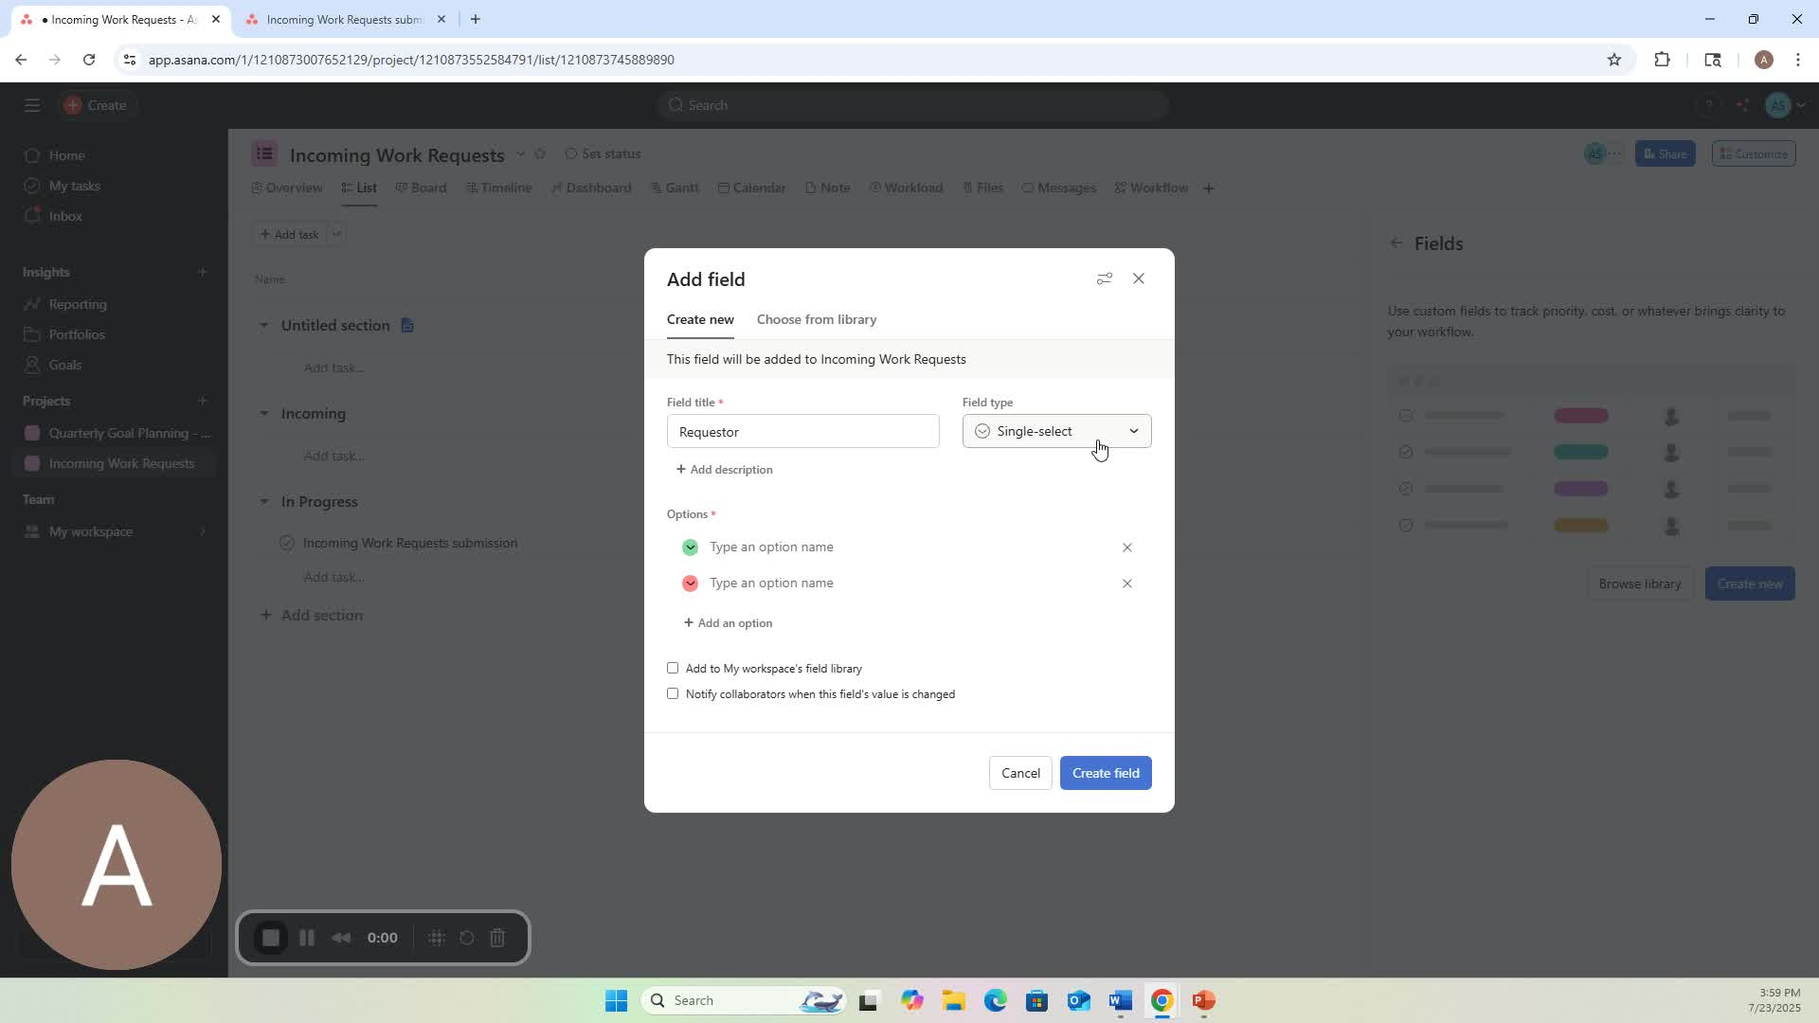

* Create custom fields to categorize requests (e.g., requester name).
* Set up automations to move tasks based on specific criteria.

**Cautionary Notes**

* Ensure that all team members have access to the necessary projects and forms.
* Regularly review and update project statuses to maintain clarity.

**Tips for Efficiency**

* Use keyboard shortcuts in Asana to speed up task creation and navigation.
* Regularly check the dashboard for updates on project statuses and tasks.