https://www.clayton.edu/news

https://www.clayton.edu/news/clayton-state-receives-2022-regents-momentum-year-award

Clayton State receives the 2022 Regents’ Momentum Year Award
(May 16, 2022) -Congratulations! Clayton State University received the 2022 Regents’ Momentum Year Award for Excellence in Teaching and Curricular Innovation on Tuesday, May 10 from the University System of Georgia (USG). In attendance were Dr.’s Mary Lamb, Sipai Klein, and Jennifer Parrott (photographed with Chancellor Sonny Perdue and Interim President Kerry L. Heyward). Klein and Parrott coordinated the Peer-Academic Mentor Program, which creates transformative experiences intended to deepen learning as a part of the first college year. The program embodies the values and approach of Momentum Year by enhancing academic belonging among students and their peer mentors.
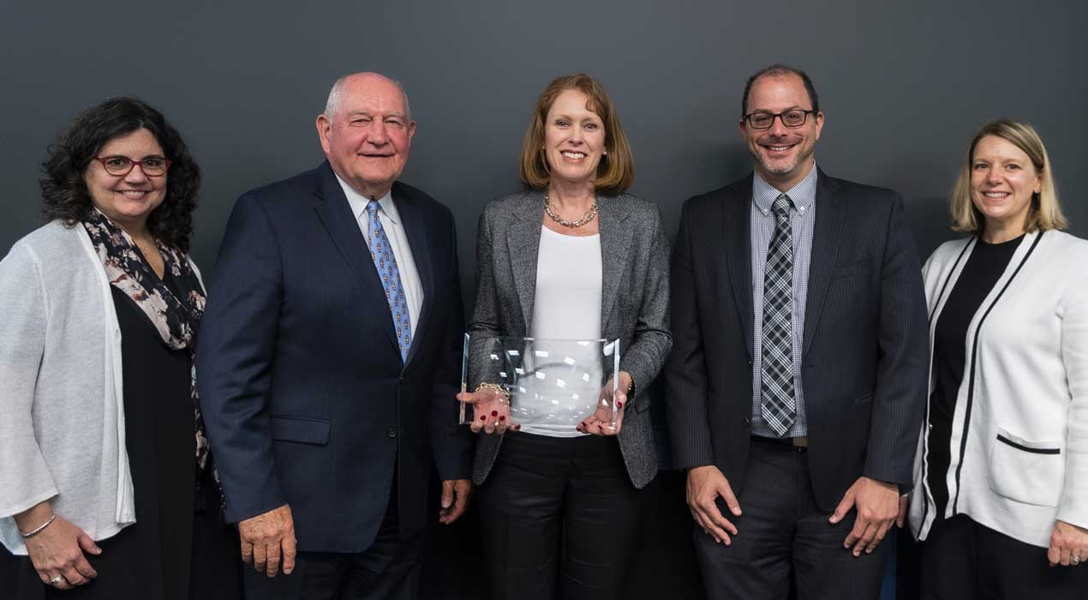
The Momentum Year Award for Excellence in Teaching and Curricular Innovation is designed to honor teaching and instruction that promotes student achievement, promotes a purposeful program and career choice, and creates an environment where positive academic mindsets thrive, catapulting students toward degree completion. Excellence in teaching first-year students is critical to increasing student retention, progression, and graduation.

https://www.clayton.edu/news/test-waived-fall-2022

Tests are Waived This Fall While We Continue to Bridge Student Success
(April 12, 2022) -Continuing with the test-optional movement that began during the COVID-19 pandemic, our university is one of 23 institutions within the USG waiving Fall 2022 ACT and SAT scores for new freshmen. This increase in our college recruitment means that thousands more applications can finally receive an automatic review and the possibility of securing the high-quality education we provide.
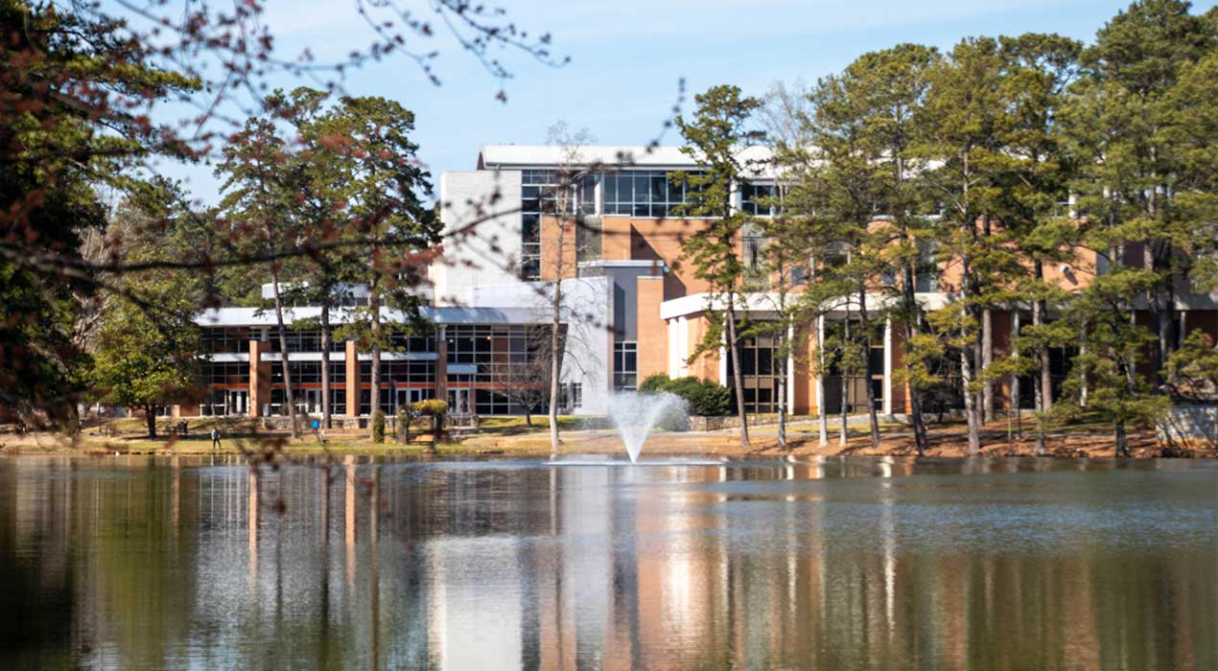
“The University System of Georgia’s approval to allow Clayton State University to be test-optional for undergraduate students for Fall 2022 will have a significant impact on providing equitable access to the transformational outcomes of a Clayton State University education,” said Dr. Eric Tack, interim vice president, Enrollment Management and Student Success. “This decision means thousands of applicants can now receive an admission decision without having to access and identify funding for the SAT or ACT. Historically, we have found that a student’s core high school GPA is the greatest predictor of a student’s likelihood to be successful in a Clayton State classroom.”
Students with a 3.0 core GPA are admitted as traditional freshmen, but if a student doesn't have the 3.0, there are two other pathways for them to be admitted to Clayton State. Even before the COVID-19 pandemic, we carefully crafted support programs to empower their belief that they can be successful.
With our Summer Bridge Program, eligible Fall 2022 freshmen with a 2.6 to 2.9 GPA, who do not meet the minimum admissions requirements, can take two courses with us this summer, and if successful can continue in the fall as a traditional freshmen. Our Summer Bridge participants live on campus and have access to additional resources such as tutoring, mentoring, and social and networking opportunities to experience Clayton State college life.
“The test-optional access gives us a chance to accept new students with the hope of having a successful transition. Our Summer Bridge Program has been highly successful and previously 100% of those students were admitted in Fall 2021 to formally start taking courses. They are now taking full course loads.” said Dr. Jill Lane, interim provost and vice president, Academic Affairs.
Eligible applicants with a 2.2 to 2.59 GPA can participate in the Laker Trailblazer Program and take courses at our university and Atlanta Metropolitan State. Participants live on our campus and have access to all student resources and activities. These courses are guaranteed to transfer between institutions and students can complete their studies here.
Dr. Lane notes that with the successful collaboration of all campus divisions and after completion of both programs, students will continue to have support in their second year and third year, helping them finally achieve their dream of a Clayton State degree.

https://www.clayton.edu/news/shelia-corona-places-in-exhibition-tributing-late-international-entertainer

Student Artist Places in Exhibition Tributing Late International Entertainer
(March 15, 2022) -Sheila Corona, a Clayton State junior, says her recent award-winning artwork posthumously honors a widely known South Korean pop idol, whose personal story remains unknown despite his international public fame. He died a mysterious, untimely death at age 27.
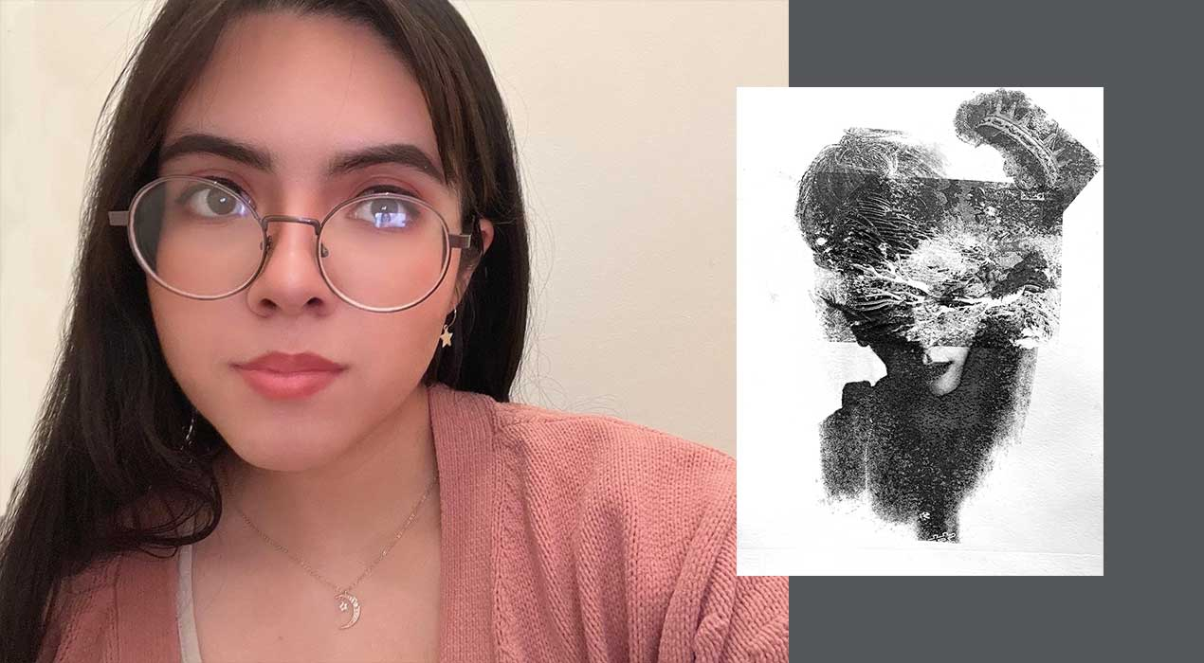
Clayton State art professor, Alan Xie, submitted her work to the Peach Belt Conference Online Art Exhibit recently and it garnered second place in the juried exhibition among nine other institutions. This is her second year participating and first-time placing in the competition. This year, her piece, “Monotype,” also the name of the medium used, tells the story of Jonghyun, a lead singer and second-generation member of the K-pop group, Shinee and contrasts his popularity with his private life.
“A part of the reason why you can’t see some of his features on his face is because we don’t always know the entire story of these idols,” said Corona. “A lot of it is a mystery but they still present themselves to the best of their abilities where fans across the world feel connected. I know I did, and I still do feel connected, especially to Jonghyun.”
In her artistic characterization of Jonghyun, Corona placed a crown near the right side of his head symbolizing that even under immense pressures as a mega entertainer, he continued to give his best to his fans, while leaving them with happy memories throughout his performance years.
The Riverdale resident said that this exhibit encouraged her to learn more about herself and her award was a humbling surprise.
“I always had doubts about my capabilities and receiving this honor came as a shock to me. It serves as motivation to keep going and challenging yourself,” she said.
This year’s Peach Belt Conference Online Art Exhibit judge and Arts Center of Greenwood gallery and marketing director, Jennifer A. Smith, noted that Corona’s monotype appealed to her immediately upon her first review of the entries.
“It is important for students to have opportunities like this to exhibit their artwork at the collegiate level alongside their peers throughout the state. These types of juried exhibitions challenge young artists to engage in healthy competition, build their curriculum vitae, and expose their artwork to arts professionals within the region,” said Smith. “(Her) particular work translates as a materialized memory. It leaves me wanting to peel back some of the layers in order to see more, read more, and know more about the story.”
As a part of the National Collegiate Athletic Association, Division II, the Peach Belt Conference provides through its dependent collegiate members a forum for student participation in athletic, academic, and co-curricular events. Its student-based art exhibition has been hosted annually for over two decades.

https://www.clayton.edu/news/shanell-mcgoy

Dr. Shanell McGoy Appointed Fellow of Practice at Center for Social Innovation and Sustainable Entrepreneurship
(March 2, 2022) -Congratulations to Dr. Shanell McGoy on her appointment as the first Fellow of Practice at the Center for Social Innovation and Sustainable Entrepreneurship (CSISE) at our College of Business, where she will work with Dr. Leon Prieto, Center Director and Associate Professor of Management, and Dr. Stacey Reynolds, Associate Director and Assistant Professor of Management.
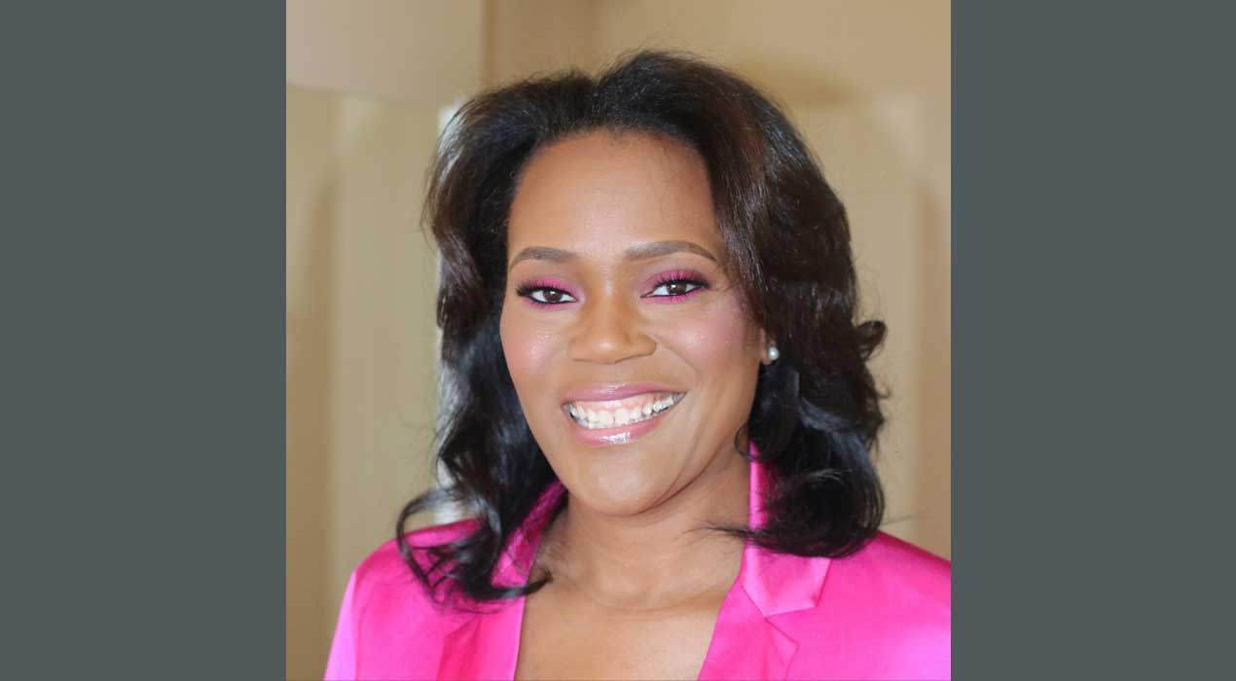
Dr. McGoy is the Director of Public Affairs and Corporate Citizenship at Gilead Sciences, Inc., where she leads U.S. Giving and the Gilead COMPASS Initiative, a 10-year, more than $100 million commitment to address the HIV/AIDS epidemic in the southern United States that supports local communities and evidence-based solutions to meet the needs of people living with and impacted by HIV/AIDS.
She has committed her 20-year career to addressing the HIV epidemic in the U.S. Additionally, with degrees in public health and health policy, and extensive experience in governmental public health, her community focus continues to alleviate barriers to achieving health equity in a variety of areas. Her background in social and environmental change will influence thought leadership to effectuate positive change.
"The appointment of Dr. McGoy as a Fellow of Practice is a major win for us because of the wealth of experience and knowledge that she brings to the students and faculty at Clayton State University," said Dr. Jacob Chacko, Dean of the College of Business. "It is great that Dr. McGoy will play a role in our center and its activities here at Clayton State as we strive to make a positive difference. Her experience will no doubt help our students develop their acumen to become social innovators and agents of change within their community."
The Center for Social Innovation and Sustainable Entrepreneurship further advances our university’s efforts to promote and grow the quality of future graduates who are equipped to take on responsibilities as future social innovators in the private and public sectors. The center engages in teaching, research, and community engagement to tackle social innovation and sustainable entrepreneurship challenges facing the community.

https://www.clayton.edu/news/partnership-with-communities-in-schools-of-atlanta

Clayton State Announces Partnership with Communities in Schools of Atlanta
(May 3, 2022) -Reports state that a significant percentage of high school students who grow up in underserved communities may never consider college as an option because of personal obligations, competing work schedules, or financial challenges. They are often the first in their homes to pursue higher education and require more supportive services to be successful, so student-centered provision and local collaboration are vital.
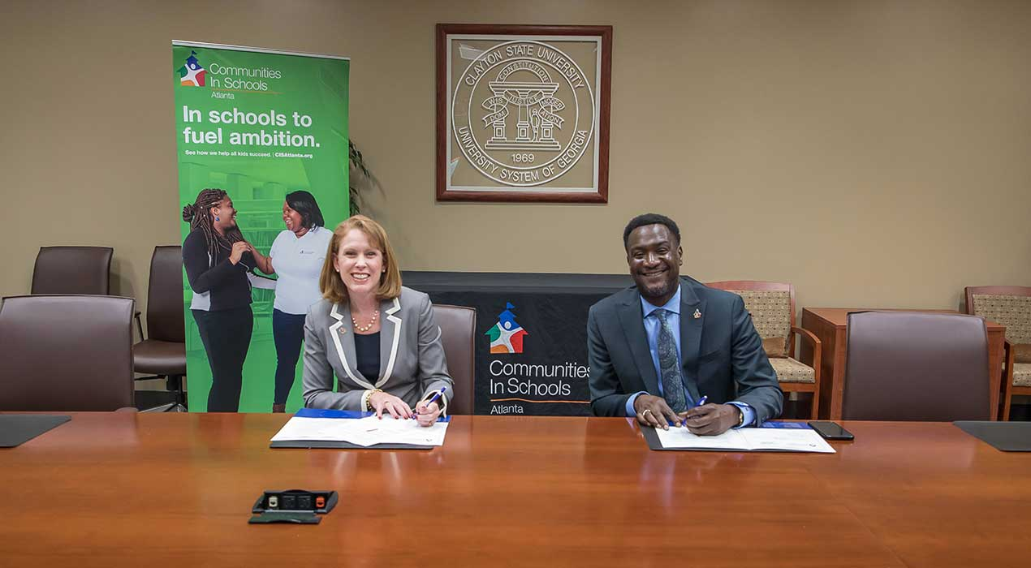
On April 22, we signed a memorandum of understanding forming a new partnership with Communities In Schools of Atlanta, a local affiliate of the nation’s largest and most effective dropout prevention program. Communities In Schools of Atlanta is expanding throughout Clayton County and this strategic partnership will help us continue to fulfill our mission to inspire, empower, and educate our region for leadership and success.
“This has been a tremendous amount of work and I want to thank everyone who has been involved. Communities in Schools does an incredible job providing services that move students from graduation to careers,” said Kerry L. Heyward, interim president. “We know that education is a transformational experience. It changes not only the individual’s life but the lives of the families that they are part of. That’s why it’s so important. Clayton State provides the types of support that Communities in Schools does in the sense that we understand that we serve first-generation students who need the support and the systems to make them successful.”
An initial conversation at a local college fair took place between Clayton State and Communities In Schools of Atlanta staff which unveiled an opportunity to service a shared audience. This collaboration will strengthen our shared goals to further bolster student success and quality of life.
Dr. Eric Tack, interim vice president of Enrollment Management and Student Success said, “This has been several years in the making. Communities in Schools of Atlanta is looking to expand its efforts and it is a recipe for success for post-secondary institutions. We are excited they chose us to be an official partner. Us coming together today at Clayton State University is not just for enrollment but helping support students through graduation where they will return to our communities.”
Our work with Communities In Schools of Atlanta will empower and equip students to overcome the barriers that stand between them and an equitable path to education.
“Our mission is to surround students with a community of support, empowering them to stay in school and achieve in life. A high school diploma is not enough. Ninety-nine percent of the students we serve are Black and brown kids from low-income situations. They live in communities that have been hit hardest by inflation,” said Frank Brown, chief executive officer, Communities In Schools of Atlanta. “We must be the innovators of a new model. That includes making sure our students graduate from college,
if that is part of their plan. We hope to have students attending and graduating from Clayton State every year.”
As Communities In Schools of Atlanta graduates become Clayton State graduates, these alumni will mentor new students and serve as a shoulder to lean on when days get tough. Despite the challenges some students face, quitting their studies at Clayton State should not be an option.
During the MOU signing, attendees heard from Sincere Perkins, a Clayton State freshman studying English to become a high school teacher. Perkins has been in state foster care services for two years and she described the support she has received from our university and Communities In Schools of Atlanta.
“Clayton State University has supported me in many ways from making sure that my tuition and fees are received timely from the Georgia Division of Family and Children Services to making sure that I have semester break housing, so I don't have to go into a foster placement,” said Perkins. “Communities In Schools of Atlanta helps me by ensuring that I am supported consistently, and I always have someone to talk to. Some of the essential living needs that I have are because of their efforts.”

